**Session 1**

1. create a HashSet class by add 10 numbers by using for loop and extra add some more objects and print the all the values.

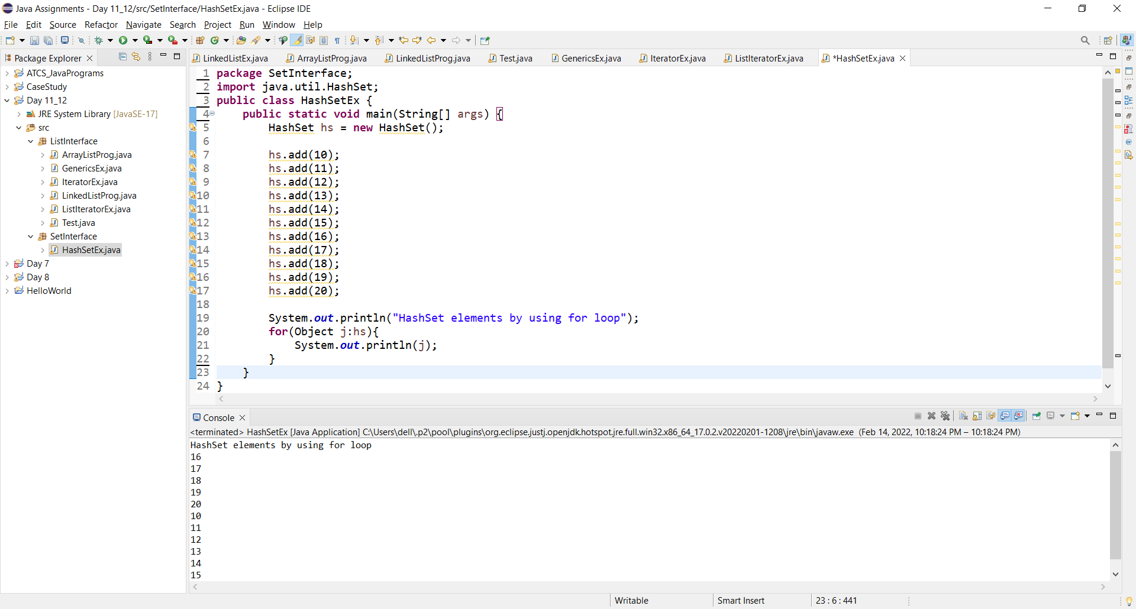

1. create a LinkedHashSet class by add 10 numbers by using for loop and extra add some more objects and print the all the values.

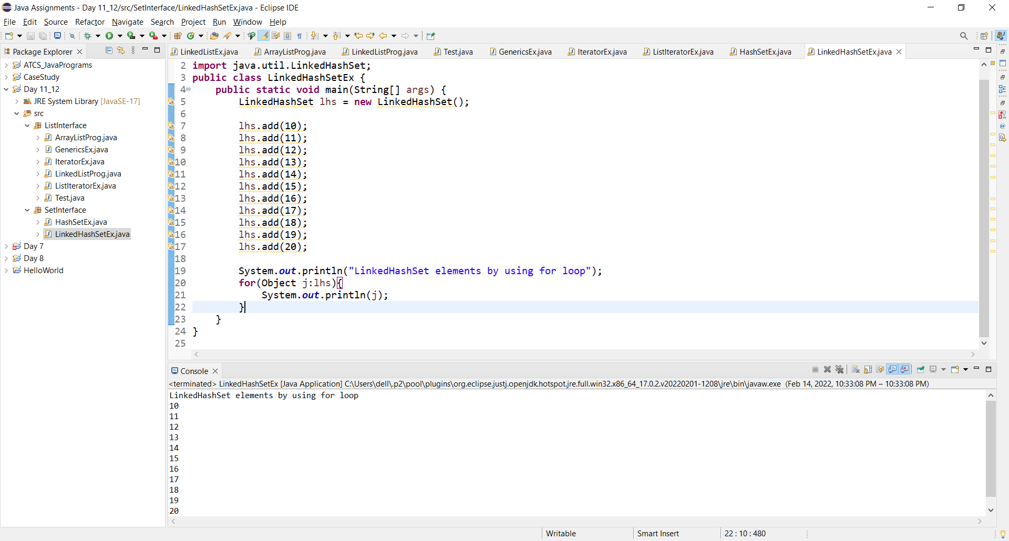

1. By using Iterator class iterate the HashSet class Elements.

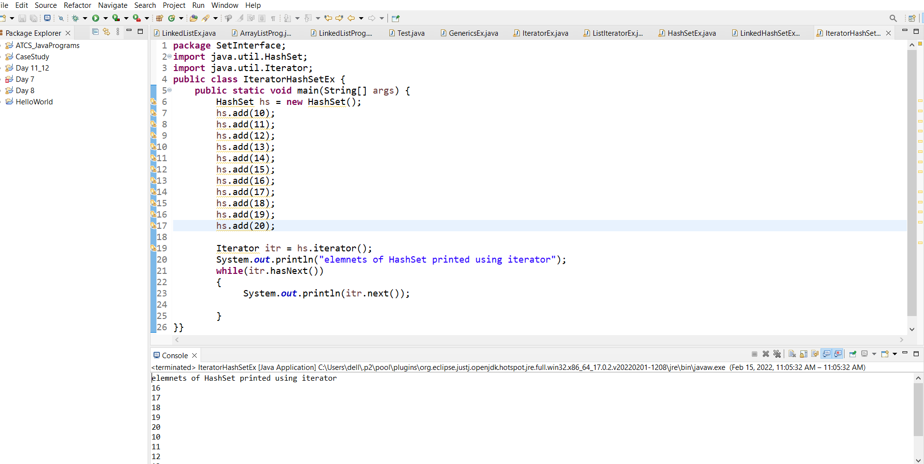

1. By using Iterator class iterate the LinkedHashSet Elements.

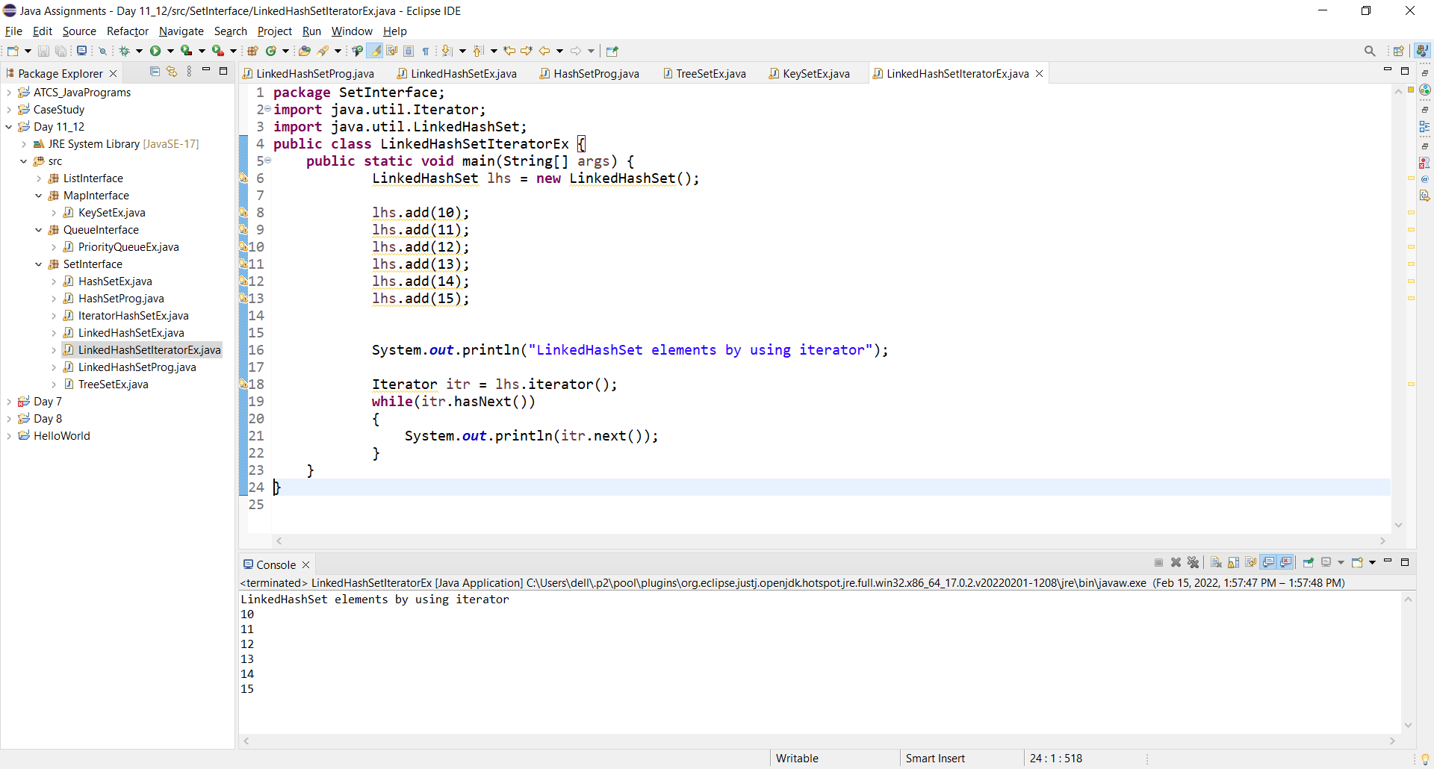

1. By using generics cretae hashset class apply some methods,addall(),remove().

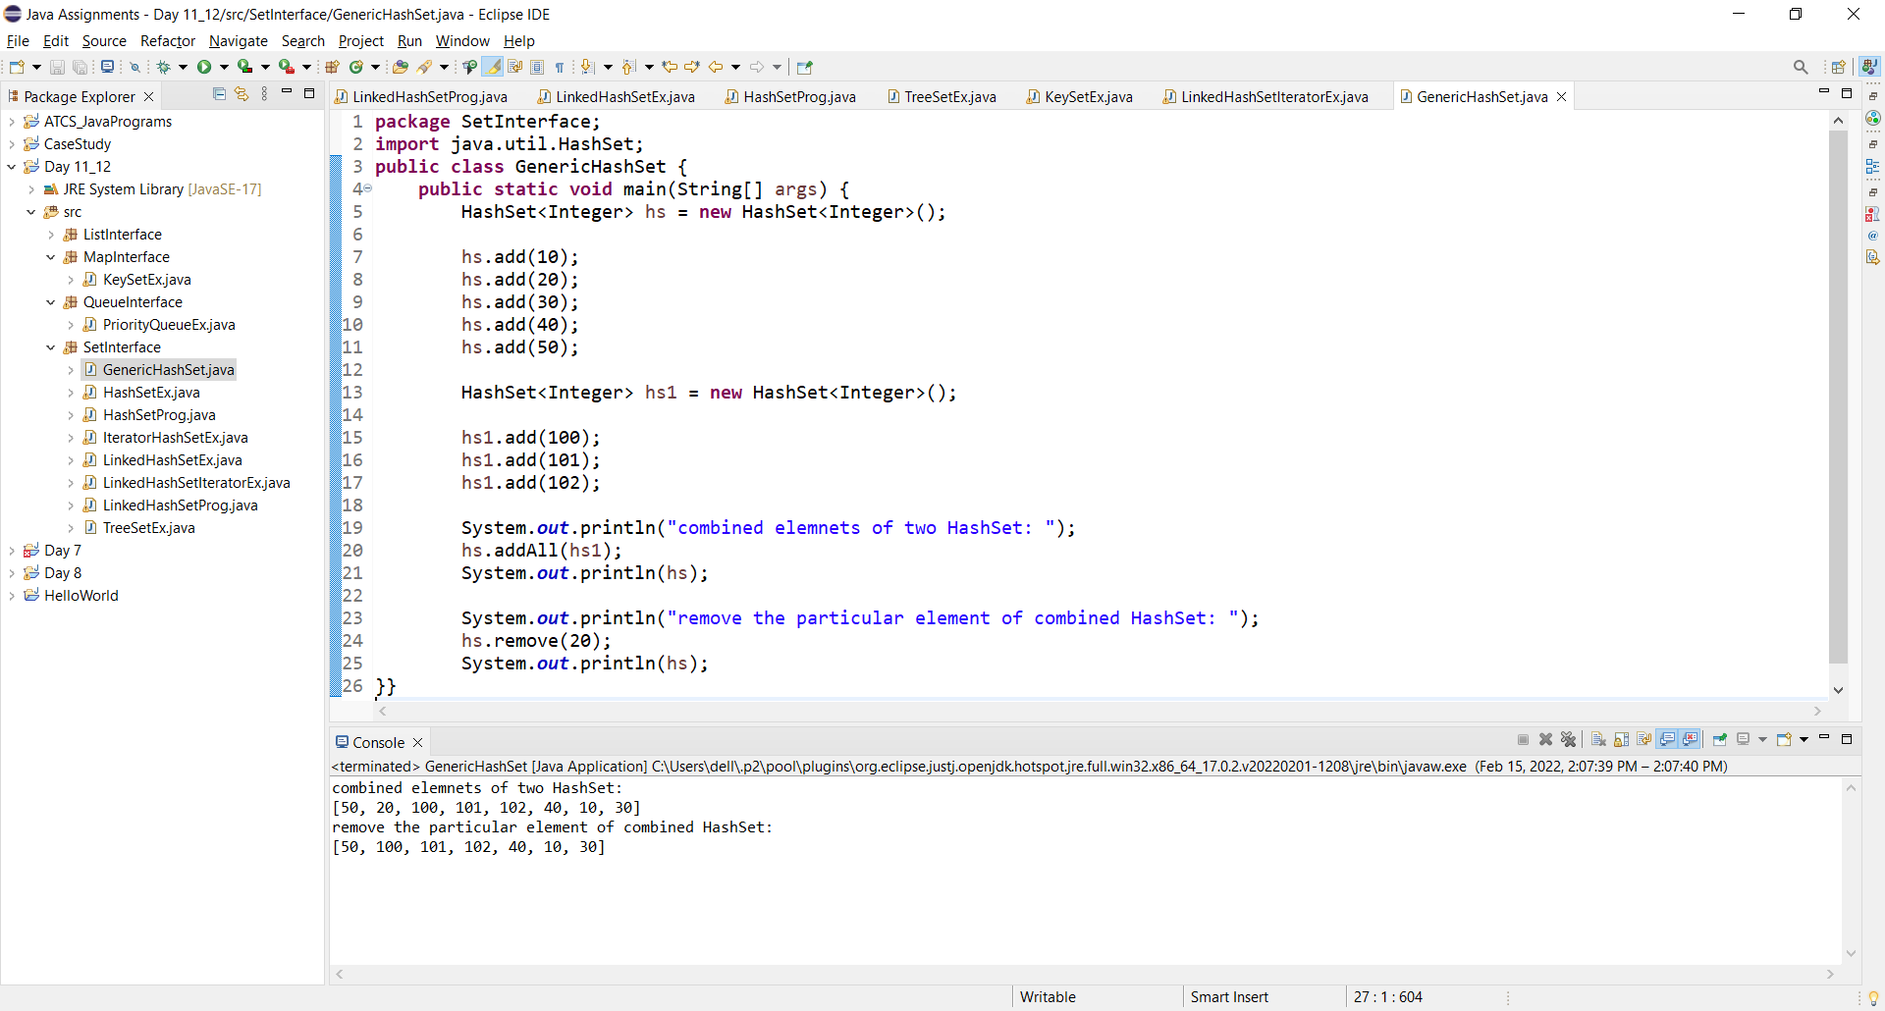

**Session 2**

1. create a class and print the elements by using keySet.

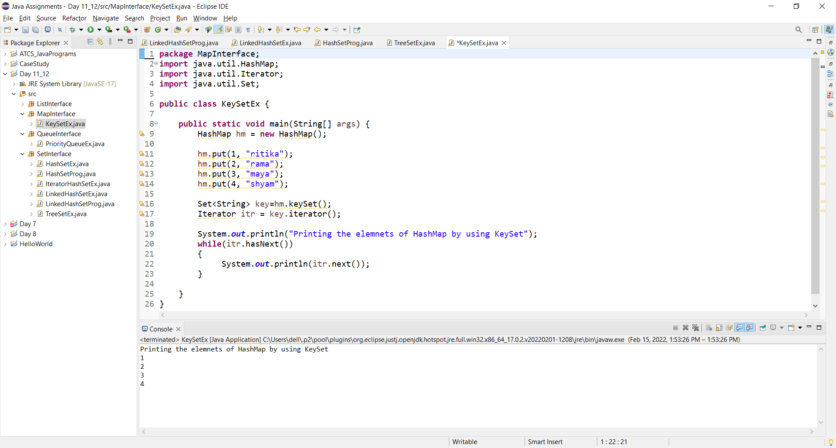

1. Create a class print all the elements with EntrySet.

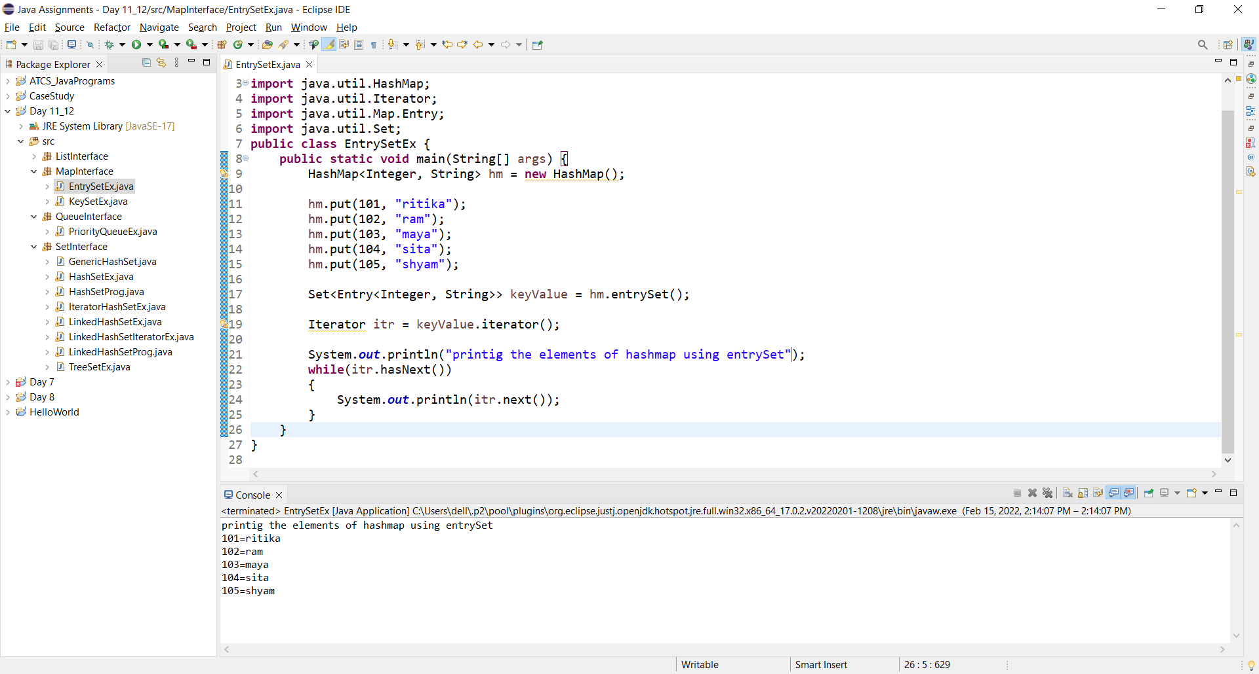

1. Create a class with HashMap use to print the values.

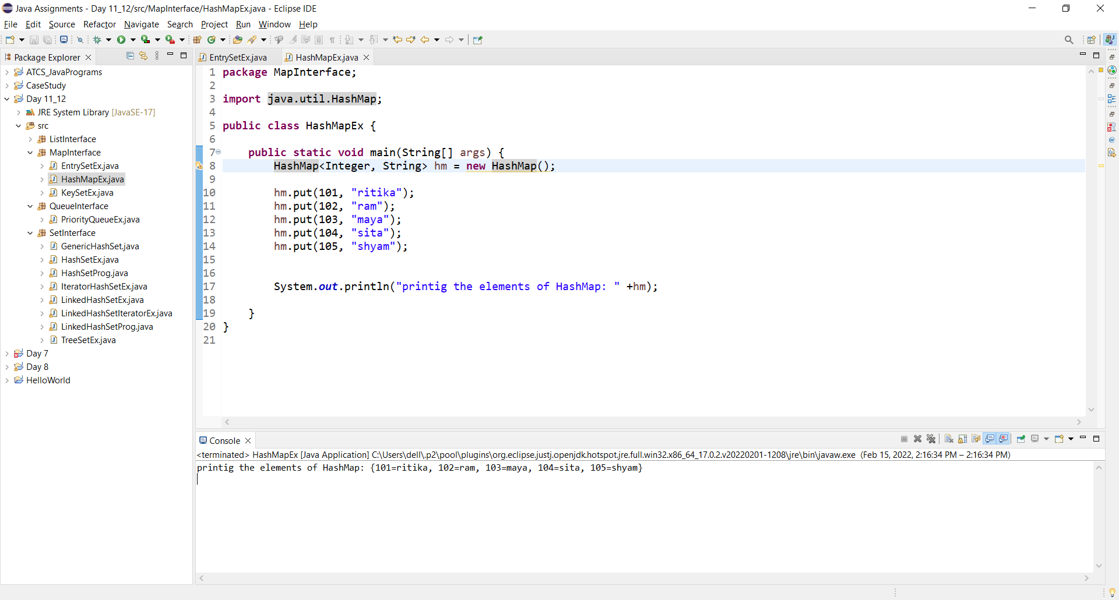

1. By Using LinkedHashMap add elements and print the values.

